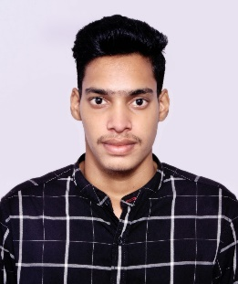**GANTA ANUDEEP**

**Email :** anudeepganta111@gmail.com

**Contact** : +91-7093739063

**LinkedIn** : https://in.linkedin.com/in/anudeep-ganta-0a287b19b

**OBJECTIVE**

Aspiring for a challenging job at a reputable firm that will allow me to grasp the field of overall quality management of projects while also contributing to the organization’s of growth and development.

**ACADEMIC QUALIFICATIONS**

|  |  |  |  |
| --- | --- | --- | --- |
| Academic Qualification | University/Board | Year | Percentage /CGPA |
| B.Tech. (ECE) | Aditya Institute Of Technolgy and Management,Tekkali | 2020-24 | 8.0 CGPA |
| Intermediate | Narayana Jr. College,Visakhapatnam | 2018-20 | 8.1 |
| SSC | Suresh High School, Parvathipuram | 2017-18 | 9.8 |

**TECHNICAL SKILLS**

**Programming :** Python, Java, C

**Development :** HTML, CSS

**Technical Skills :** MATLAB,PSPICE,EASY EDA,MICROSOFT OFFICE,

MICROSOFT WORD

**CERTIFICATIONS**

* Productivity Enhancement Tools
* PCB(Printed Circuit Boards) Designing

**CO CURRICULAR ACTIVITIES**

* Runner up in a Cricket tournament conducted by AITAM College.
* Performed stage dancing in Youth festivals.
* An active member of NSS.

**PERSONAL DETAILS**

**Father Name :** Ganta Ramarao

**Date of Birth :** 24th November 2002

**Languages Known :** English, Telugu

**Hobbies/Interests :** Playing Cricket, Travel,

**Address         :**  D/no- 7-73, seethanagaram (Village/Post/ Mandal),

                            Manyam Parvathipuram (District),

                            Andhra Pradesh (State), Pin code: 535546

**SALUTATION**

**Here by,I solemnly assure that the above information given by me is true to the best of my knowledge.If any information found to be faulty,I will bear the responsibility of it.**

**Date:** 26/07/2023 GANTA ANUDEEP

**Place:** Tekkali Signature